Setting up EC to use DB2 in z/OS (enable spatial operation)

- IPL the EC with the following setting
  - Change the New Catalog to N – prevent erasing existing data when re-IPL (especially every Sunday) – need further investigation (can use Y for now)
  - Type DYN in the TCPIP column
  - Choose MVS ZS21PA - z/OS version 2.1
  - Type NN under 1st DB2 for using DB2 version 11
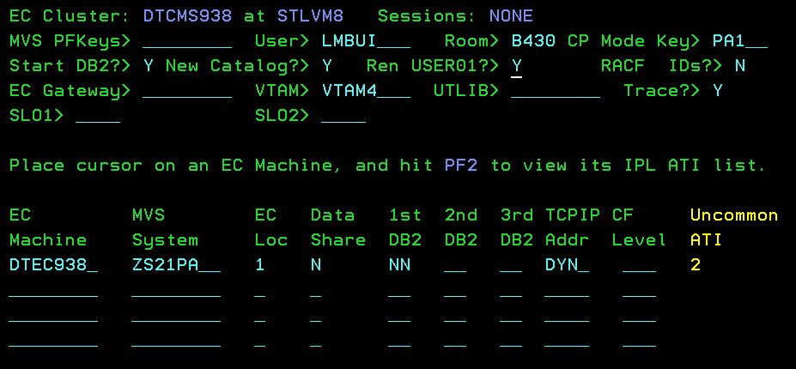
  - Hit F2 on the column “Uncommon ATI”
  - Change the disk space to 600
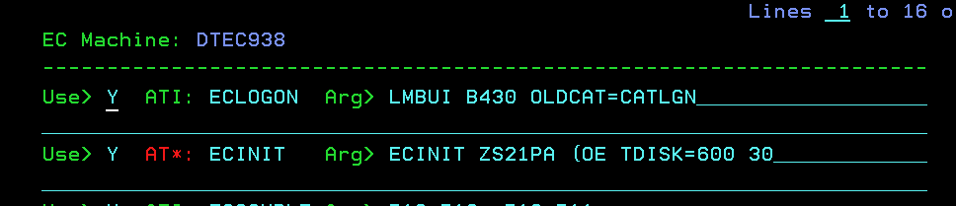
  - Change the command to start DB2 to “-DB2ASTART DB2, PARM=DB2AZNS”. ‘ZNS’ means to turn on ddf and no datasharing.
  - When the EC is up, type -db2a dis ddf to see the db2a TCPIP status. It should contains the IP address.
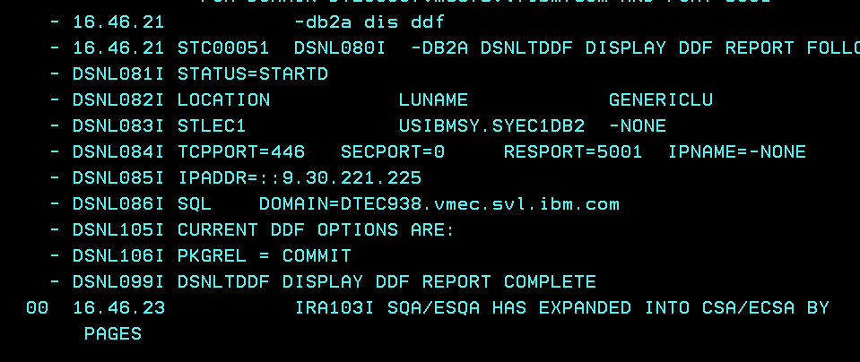
  - If there is no IP, you might want to stop and start db2 manually. The command to stop is “-DB2ASTOP DB2”. The command to start db2 with ddf turn on is “-DB2ASTART DB2,PARM=DB2AZNS”. If you still don’t see the IP address, you would have to set up the TCPIP configuration for the EC (there is instructions for this)

- Go to your VM14, tcpun the job “DSN5SENB PARMV11” to active enable the spatial data for the DB2 in the EC. Check the result if it is successful.
